Oracle Access Management WebPass (IDM Single Node) - Blueprint Information

# Overview

The purpose of this document is to describe the Oracle Access Management WebPass blueprint (as part of the IDM Single Node blueprint) in detail. The goal of the blueprint is to allow for provisioning and configuration of a single node Oracle Access Management WebPass (OAM WP) instance in an automated and repeatable fashion.

The following components and versions are installed as part of the OAM WP instance:

1. Oracle HTTP Server (OHS) 10.1.3.0.0
2. OAM WP Release 10.1.4.2.0.09 BP 09

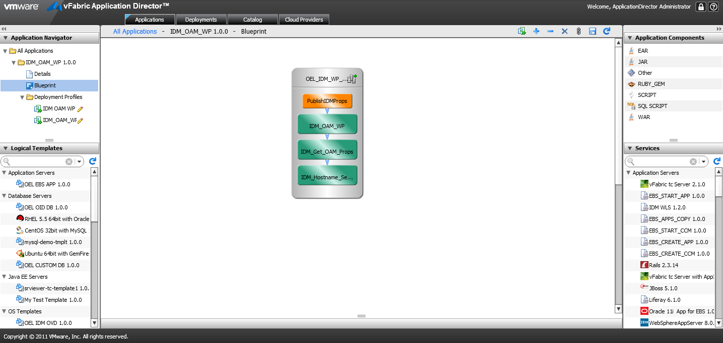

# High level BLUEPRINT Design

Conceptually, the blueprint design consists of the tasks described below. These tasks are listed in chronological order:

1. Setup Host Name
2. Retrieve Oracle Access Management (OAM) Properties
3. Install OHS 10.1.3.0.0 & OAM WP Release 10.1.4.2.0.09 BP 09
4. Publish Identity Management (IDM) Properties for SOA Integration

## Files

You will need access to create the following file repository that contains the necessary installers and configuration files needed. We will refer to this repository as the “Mount Point Location” in this document.

$MOUNTPOINTLOCATION/IDM:

ohs/ Installation and configuration directory of OHS 10.1.3.0.0

soa_linux_x86_101310_disk1.cpio Installation package of OHS 10.1.3.0.0 (Note: this package needs to be extracted in the same directory)

Templates/ OHS installation and configuration templates

ohs_install.rsp OHS silent installation response file Template

rootsh_rsp.txt Response file when running “root.sh”

staticports.ini OHS port configuration file

oam/ Installation and configuration directory of OAM

oam_101401/ Installation packages of OAM 10.1.4.0.1

oam_101420_patchset/ Installation upgrade patches of OAM 10.1.4.2.0

oam_101420_BP / Installation bundle patches of OAM 10.1.4.2.0

gcc_lib/ GCC libraries required by OAM installation

Templates/ OAM WP installation and configuration templates

wp_install_options.txt OAM WP silent installtion response file Template

simpleCA.tar OAM Certificate package

opmn_fix.xml OHS environment fix XML

workflows/ Customized OAM workflow configuration files

perforce/Templates/ Perforce templates used for inter-blueprint communications

idm.properties IDM properties file for SOA integration

You will also need below files to configure the scripts and services within this blueprint. Please refer to the following sections for details and their corresponding script/service.

IDM_Hostname_Setup_INSTALL.txt

IDM_Get_OAM_Props_INSTALL.txt

IDM_OAM_WP_INSTALL.txt

IDM_OAM_WP_CONFIGURE.txt

PublishIDMProps_INSTALL.txt

## Setup Host Name

The “Setup Host Name” task sets the hostname for the machine that’s provisioned. It’s defined as a blueprint service.

Properties:

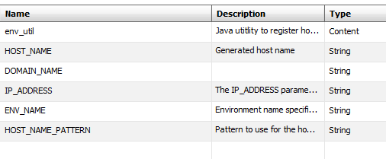

Actions:

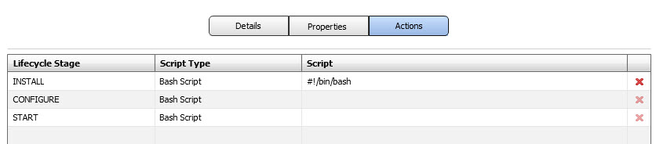

Install Script:

Please refer to file **IDM_Hostname_Setup_INSTALL.txt** to copy the script as the INSTALL Bash Script.

## Retrieve Oracle Access Management (OAM) Properties

The “Retrieve Oracle Access Management (OAM) Properties” task retrieves the OAM information that OAM WP needs to connect to from Perforce. It’s defined as a blueprint service.

Properties:

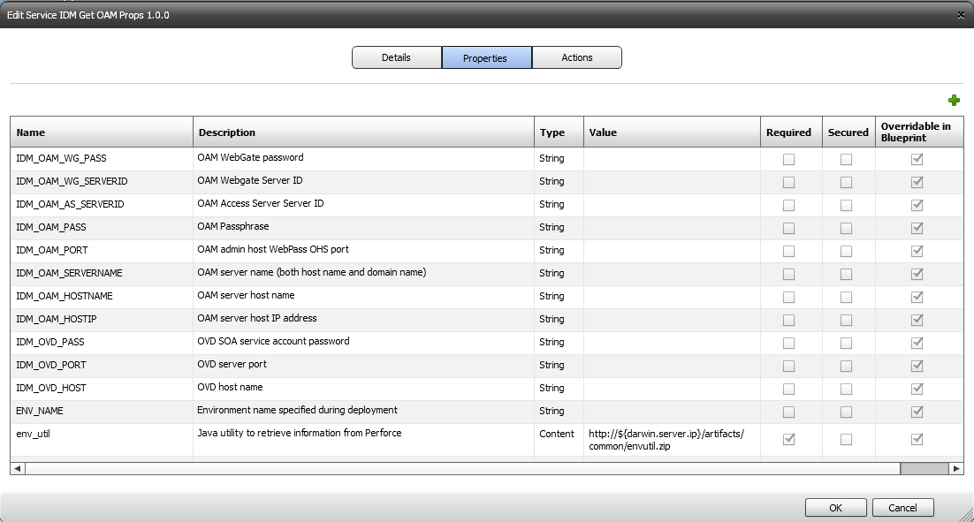

Actions:



Install Script:

Please refer to file **IDM_Get_OAM_Props_INSTALL.txt** to copy the script as the INSTALL Bash Script.

## Install OHS 10.1.3.0.0 & OAM WP Release 10.1.4.2.0.09 BP 09

The “Install OHS 10.1.3.0.0 & OAM WP Release 10.1.4.2.0.09 BP 09” task installs an OHS instance along with an OAM WP server instance. It’s defined as a blueprint service.

Properties:

Service Definition

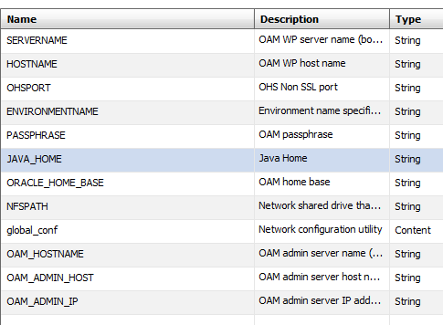

Actions:

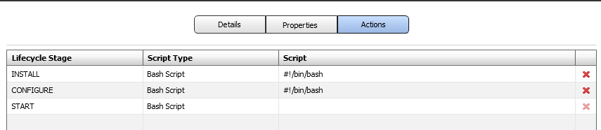

Install Script:

Please refer to file **IDM_OAM_WP_INSTALL.txt** to copy the script as the INSTALL Bash Script.

Please refer to file **IDM_OAM_WP_CONFIGURE.txt** to copy the script as the CONFIGURE Bash Script.

## Publish IDM Properties

The “Publish IDM Properties” task publish the IDM information to Perforce for the purpose of SOA integration. It’s defined as a blueprint script.

Properties:

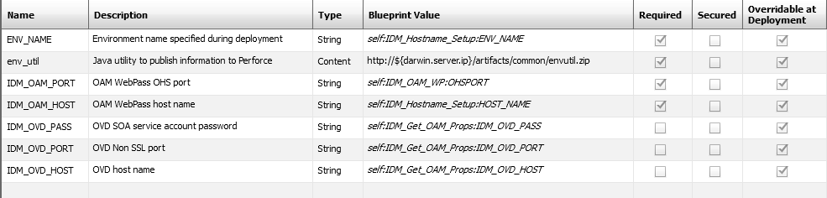

Actions:



Install Script:

Please refer to file **PublishIDMProps_INSTALL.txt** to copy the script as the INSTALL Bash Script.